**PRACTICAL 6**

**AIM:** To create the following topology

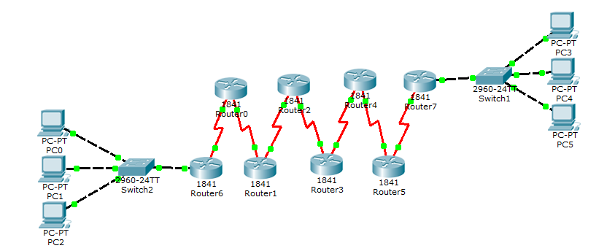

**PC0:**

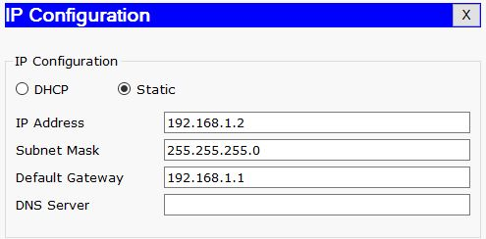

**PC1:**

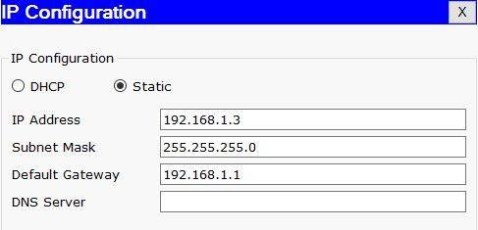

**PC2:**

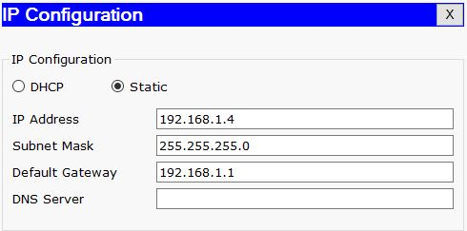

**PC3:**

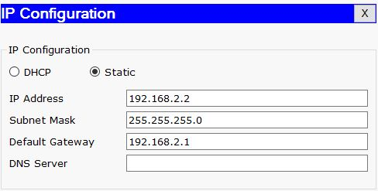

**PC4:**

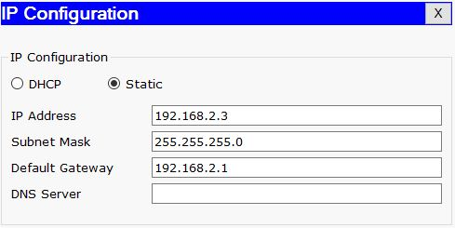

**PC5:**

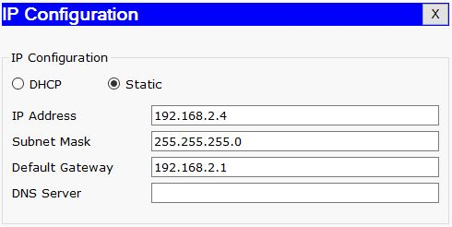

**Router0:**

Router>enable

Router#configure terminal

Enter configuration commands, one per line. End with CNTL/Z.

Router(config)#router rip

Router(config-router)#

Router(config-router)#exit

Router(config)#interface FastEthernet0/0

Router(config-if)#

Router(config-if)#exit

Router(config)#interface Serial0/1/0

Router(config-if)#ip address 192.168.3.2 255.255.255.0

Router(config-if)#clock rate 72000

This command applies only to DCE interfaces

Router(config-if)#no shutdown

Router(config-if)#

%LINK-5-CHANGED: Interface Serial0/1/0, changed state to up

Router(config-if)#exit

Router(config)#interface Serial0/1/1

Router(config-if)#

%LINEPROTO-5-UPDOWN: Line protocol on Interface Serial0/1/0, changed state to up

ip address 192.168.4.1 255.255.255.0

Router(config-if)#clock rate 72000

Router(config-if)#no shutdown

**Router1:**

Router>enable

Router#configure terminal

Enter configuration commands, one per line. End with CNTL/Z.

Router(config)#interface Serial0/1/1

Router(config-if)#ip address 192.168.4.2 255.255.255.0

Router(config-if)#clock rate 72000

This command applies only to DCE interfaces

Router(config-if)#no shutdown

Router(config-if)#

%LINK-5-CHANGED: Interface Serial0/1/1, changed state to up

Router(config-if)#exit

Router(config)#interface Serial0/1/0

Router(config-if)#ip address 192.168.5.1 255.255.255.0

Router(config-if)#

%LINEPROTO-5-UPDOWN: Line protocol on Interface Serial0/1/1, changed state to up

clock rate 72000

Router(config-if)#no shutdown

**Router2:**

Router>enable

Router#configure terminal

Enter configuration commands, one per line. End with CNTL/Z.

Router(config)#interface Serial0/1/0

Router(config-if)#ip address 192.168.5.2 255.255.255.0

Router(config-if)#clock rate 72000

This command applies only to DCE interfaces

Router(config-if)#no shutdown

Router(config-if)#

%LINK-5-CHANGED: Interface Serial0/1/0, changed state to up

Router(config-if)#exit

Router(config)#interface Serial0/1/1

Router(config-if)#ip address 192.168.6.1 255.255.255.0

Router(config-if)#clock rate 72000

Router(config-if)# no shutdown

%LINEPROTO-5-UPDOWN: Line protocol on Interface Serial0/1/0, changed state to up

**Router3:**

Router>enable

Router#configure terminal

Enter configuration commands, one per line. End with CNTL/Z.

Router(config)#interface Serial0/1/1

Router(config-if)#ip address 192.168.6.2 255.255.255.0

Router(config-if)#clock rate 72000

This command applies only to DCE interfaces

Router(config-if)#no shutdown

Router(config-if)#

%LINK-5-CHANGED: Interface Serial0/1/1, changed state to up

Router(config-if)#exit

Router(config)#interface Serial0/1/0

Router(config-if)#

%LINEPROTO-5-UPDOWN: Line protocol on Interface Serial0/1/1, changed state to up

ip address 192.168.7.1 255.255.255.0

Router(config-if)#clock rate 72000

Router(config-if)#no shutdown

**Router4:**

Router>enable

Router#configure terminal

Enter configuration commands, one per line. End with CNTL/Z.

Router(config)#interface Serial0/1/0

Router(config-if)#ip address 192.168.7.2 255.255.255.0

Router(config-if)#clock rate 72000

This command applies only to DCE interfaces

Router(config-if)#no shutdown

Router(config-if)#

%LINK-5-CHANGED: Interface Serial0/1/0, changed state to up

Router(config-if)#exit

Router(config)#interface Serial0/1/1

Router(config-if)#ip address 192.168.8.1 255.255.255.0

Router(config-if)#

%LINEPROTO-5-UPDOWN: Line protocol on Interface Serial0/1/0, changed state to up

clock rate 72000

Router(config-if)#no shutdown

**Router5:**

Router>enable

Router#configure terminal

Enter configuration commands, one per line. End with CNTL/Z.

Router(config)#interface Serial0/1/1

Router(config-if)#ip address 192.168.8.2 255.255.255.0

Router(config-if)#clock rate 72000

This command applies only to DCE interfaces

Router(config-if)#no shutdown

Router(config-if)#

%LINK-5-CHANGED: Interface Serial0/1/1, changed state to up

Router(config-if)#exit

Router(config)#interface Serial0/1/0

Router(config-if)#

%LINEPROTO-5-UPDOWN: Line protocol on Interface Serial0/1/1, changed state to up

ip address 192.168.9.1 255.255.255.0

Router(config-if)#clock rate 72000

Router(config-if)#no shutdown

**Router6:**

Router>enable

Router#configure terminal

Enter configuration commands, one per line. End with CNTL/Z.

Router(config)#interface FastEthernet0/0

Router(config-if)#no ip address

Router(config-if)#ip address 192.168.1.1 255.255.255.0

Router(config-if)#no shutdown

Router(config-if)#

%LINK-5-CHANGED: Interface FastEthernet0/0, changed state to up

%LINEPROTO-5-UPDOWN: Line protocol on Interface FastEthernet0/0, changed state to up

Router(config-if)#exit

Router(config)#interface Serial0/1/0

Router(config-if)#ip address 192.168.3.1 255.255.255.0

Router(config-if)#clock rate 72000

Router(config-if)#no shutdown

**Router7:**

Router>enable

Router#configure terminal

Enter configuration commands, one per line. End with CNTL/Z.

Router(config)#interface Serial0/1/0

Router(config-if)#ip address 192.168.9.2 255.255.255.0

Router(config-if)#clock rate 72000

This command applies only to DCE interfaces

Router(config-if)#no shutdown

Router(config-if)#

%LINK-5-CHANGED: Interface Serial0/1/0, changed state to up

Router(config-if)#exit

Router(config)#interface FastEthernet0/0

Router(config-if)#ip address 192.168.2.1 255.255.255.0

Router(config-if)#no shutdown

Router(config-if)#

%LINK-5-CHANGED: Interface FastEthernet0/0, changed state to up

%LINEPROTO-5-UPDOWN: Line protocol on Interface FastEthernet0/0, changed state to up

**IP Routes:**

**Router0:**

Router(config)#router rip

Router(config-router)#network 192.168.1.0

Router(config-router)#network 192.168.3.0

**Router1:**

Router(config)#router rip

Router(config-router)#network 192.168.3.0

Router(config-router)#network 192.168.4.0

**Router2:**

Router(config)#router rip

Router(config-router)#network 192.168.4.0

Router(config-router)#network 192.168.5.0

**Router3:**

Router(config)#router rip

Router(config-router)#network 192.168.5.0

Router(config-router)#network 192.168.6.0

**Router4:**

Router(config)#router rip

Router(config-router)#network 192.168.6.0

Router(config-router)#network 192.168.7.0

**Router5:**

Router(config)#router rip

Router(config-router)#network 192.168.7.0

Router(config-router)#network 192.168.8.0

**Router6:**

Router(config)#router rip

Router(config-router)#network 192.168.9.0

Router(config-router)#network 192.168.8.0

**Router7:**

Router(config)#router rip

Router(config-router)#network 192.168.9.0

Router(config-router)#network 192.168.2.0

**Output:**

